Data Streaming Algorithms - Final project
Exploring methods for efficient MinHash based retrieval expanding Dr. Aviv Yehezkel’s earlier work

Tamar Azoulay – 311224182

Shahar Ziv 312533185

Abstract - Expanding on Dr. Aviv Yehezkel’s earlier work [1], we set out to test min-hash based retrieval methods. As Gen AI becomes increasingly integral in our everyday life, efficient methods to retrieve information from a corpus are required. In this paper, we explore different variations of the min-hash algorithm, as well as the complementing clustering and querying methods. We test accuracy and performance, and present the results here
I. Introduction
Information retrieval initially relied on exact keyword matching and statistical algorithms. These systems looked at the frequency of words but lacked an understanding of the actual meaning or context of a query.
- TF-IDF (Term Frequency-Inverse Document Frequency) laid the early mathematical groundwork by scoring documents based on how often a specific keyword appeared.
- BM25 (Best Matching 25) significantly refined this approach using probabilistic models. It became the industry standard for search engines for decades and is still highly relevant in modern hybrid search system [2].
With the invention of the Transformer architecture, retrieval shifted from lexical (keyword) matching to semantic understanding. Text was converted into vector embeddings—mathematical representations of meaning. Dense Passage Retrieval (DPR): Researchers proved that neural networks could map both questions and documents into a shared mathematical space. By calculating the distance between these vectors, DPR could retrieve documents that answered a user's question, even if the exact keywords didn't match.
As Large Language Models (LLMs) grew in popularity, they hit a wall: they often hallucinated facts and their internal knowledge was frozen in time. The solution was bridging the gap between neural retrieval and text generation. The “Retrieval-Augmented Generation” (RAG) Paradigm, coined by researchers at Meta, introduced a system that paired a dense retriever (DPR) with a generative model (like T5). Instead of relying purely on the model's internal memory, the system first searched an external database (like Wikipedia) and fed those facts into the LLM to generate an accurate, grounded response [3].
In his work [1], Yehezkel introduced an approach for testing the trustworthiness of GenAI’s outputs by retrieving the references to the output. That approach is based on 2 parts:
- Sketching and clustering the retrieval corpus. The sketching is done using MinHashing the documents, then clustering them using DBSCAN.
- Querying the DBSCAN for the output. Sketching the output using the same MinHash algorithm, then calculating their Jaccard similarity to the centroid of each cluster and returning the closest cluster(s) to the output.
Using this approach, retrieval is sublinear in the corpus size. Denoting $k$ as the output size and $m$ as the number of permutations for each MinHash sketch, sketching the has a complexity of $O(kn)$ [4]. Denoting $s$ to be the number of clusters in the DBSCAN structure, the querying of the structure has a complexity of $O(sm)$. Overall, that give us $o(n)$ complexity, where n is the number of documents in the corpus.
This paper seeks to take that approach and test it to RAG instead of referencing. The key differences between them, is the size of the query. As GenAI’s output can be very long, a user’s query is usually shorter, typically a single sentence. The corpus however, stays the same length.
In our work we test the original approach, as well as suggest to methods both for the sketching and the clustering of the data.
II. Related work
Johnson-Lindenstrauss (JL) Lemma [5]: a fundamental mathematical theorem in the field of dimensionality reduction, provides an important basis for Yehezkel’s paper. Given $0<ϵ<1$, and X be a set of m points in a high-dimensional Euclidean space $R^{N}$, let $k≥\frac{8\ln{m}}{ϵ^{2}}$. Then there exists a linear mapping $f:R^{N}→R^{k}$ such that for all pairs of points $u, v∈X$, the squared Euclidean distance between them is preserved within a factor of $1±ϵ$: $(1 - ε)‖u - v‖² ≤ ‖f(u) - f(v)‖² ≤ (1 + ε)‖u - v‖²$. In our work, we will reduce the dimensions of our corpus documents to the number of permutations in MinHash structure. We chose 128 as it is considered the go-to dimensions for MinHash.
Jaccard similarity estimation: Also forms a strong basis for Yehezkel’s work, the Jaccard [6] similarity is used to determine the similarity between two sets. It is widely used in various fields, such as information retrieval and data mining. Given two sets A and B, their Jaccard similarity is defined as:
$$J\left(A,B\right)=\frac{\left|A∩B\right|}{\left|A∪B\right|}$$
This similarity forms the basis of comparing 2 MinHash structures.
Probability Jaccard similarity [7]: A variant of the Jaccard similarity suitable for weighted sets. It is defined as:
$$J_{P}\left(p, q\right) = \sum_{x ∈ X}{ \frac{1}{\sum_{y ∈ X}{\max\left( \frac{p\left(y\right)}{p\left(x\right)}, \frac{q\left(y\right)}{q\left(x\right)} \right)} }}$$
The Probability Jaccard similarity is Pareto optimal [7] and was analyzed in detail and presented together with an appropriate locality-sensitive hash algorithm in [7]:
$$h_{k}\left(d\right)∼ Exp\left(λw\left(d\right)\right)∼\frac{1}{λw(d) }Exp(1)$$
which yield hash values distributed exponentially with rate proportional to the weight $w\left(d\right)$ of the given element d. The Probability Jaccard similarty forms the basis hashing method for ProbMinHash [8], a weighted variant of the MinHash algorithm we will use.
ProbMinHash [8]: A class of efficient algorithms designed to estimate the similarity between weighted sets or probability distributions. Building upon the theoretical foundation of [7], Ertl's ProbMinHash algorithms drastically reduce the computational overhead required to generate hash signatures. By allowing data to be processed in a single, continuous pass (streaming), these algorithms provide an unbiased, fast, and memory-efficient way to compute the Probability Jaccard Similarity. In out tests, we used ProbMinHash4, as we sought it to be the most efficient and most accurate of the class. A full python implementation is provided in the project.
DBSCAN Clustering [1]: The DBSCAN clustering algorithm is a machine learning clustering technique. It runs without the need to specify in advance the number of clusters, unlike k-means [9]. DBSCAN clusters data instances with nearby neighbors based on the minimal distance parameter inserted to it and marks as outliers data instances with too far nearest neighbors. The running time complexity of DBSCAN is typically $O(n ⋅\log{n})$ with a worst case of $O\left(n^{2}\right)$, with n being the number of data instances in the corpus.
Locality-Sensitive hashing(LSH) [10]: an algorithmic technique designed to dramatically speed up nearest-neighbor searches by intentionally maximizing hash collisions for similar items, rather than avoiding them like traditional hash functions. In LSH, a high-dimensional signature is divided into $b$ bands consisting of $r$ rows. The mathematical engine driving this technique is the probability that two documents will hash to the exact same bucket in at least one of those bands, which is defined by the formula$P=1-{\left(1-s^{r}\right)}^{b}$, where $s$ is the true similarity (such as the Jaccard index) between the items. This equation naturally forms a steep S-curve, ensuring that document pairs with a similarity $s$ above your target threshold have a collision probability $P$ approaching 1 (guaranteeing retrieval), while dissimilar items have a probability approaching 0 (safely ignoring them without a linear scan).
MinHashLSH [11]: A pipeline approach for creating MinHash signatures, and then passing them into the LSH structure, clustering similar structures together.
TF-IDF [12]: Term Frequency-Inverse Document Frequency, is a numerical statistic used in information retrieval and text mining to reflect how important a word is to a document within a larger collection or corpus. The "Term Frequency" (TF) component measures how often a word appears in a specific document, while the "Inverse Document Frequency" (IDF) component penalizes words that appear frequently across the entire dataset (like "the" or "is"). By multiplying these two values, the algorithm highlights unique, content-bearing words that characterize a specific document's topic while filtering out common noise. The TF-IDF will provide the weights we use for the ProbMinHash4
III. The tested approaches
In his article, Yehezkel’s approach involves using the basic MinHash algorithm, clustering it with the DBSCAN algorithm and then querying each cluster by it’s centroid to find the closest to it. In our work, we will explore using this method for retrieval, while also combining them with the MinHashLSH and the ProbMinHash4. The basic algorithm we explore then is:
Algorithm 1: Base structure for our retrieval systems
Input: w: Set of of terms, weighted or otherwise
Output: R, the rerieved documents from the corpus.
Let C be our clustered corpus.
$$w^{'}=Sketch\left(w\right) \\ R=Query\left(w^{'}, C\right)$$
Return R

We test these approaches against the baseline Classic TF-IDF cosine similarity and the benchmark BM25 approach, in both performance and accuracy.
For all tests, we used the MS-MARCO dataset – a dataset of real passage retrievals and the queries that got them. Our corpus will be the passage retrievals and our queries will be the dataset queries. In all cases, we used unigrams and bi-grams [6] as our search terms. Additionally, in all cases we removed basic stop words and added basic stemming to increase accuracy.
Vectorization: We used 2 vectorizers. For the MinHash algorithm, the terms are not weighted, so we used a basic vectorizer that gives us the unigrams and bigrams of the text. Of course, they are unique in their frequencies matter not in basic MinHash. For the ProbMinHash, we used a TF-IDF vectorizer. That does mean, that prior to vectorizing the data we pre-processed by fitting the vectorizer with the data.
Clustering: For clustering, we used methods, the LSH and the DBSCAN. For the LSH, the algorithm looked like this:
Algorithm 2: BuildLSHCorpus
Input:
D, the set of document to cluster
SK, The sketching algorithm, either ProbMinHash4 or MinHash.
Output: C, the clustered corpus index
$$index=MinHashLSH()$$
$D^{'}=Vectorize\left(D\right)$, vectorize the documents into stemmed, n-grams terms with removed stopwords
For $d∈D^{'}$:
$$sketch=SK\left(d\right) \\ index.insert\left(sketch\right)$$
Return index

For our tests we used a threshold of 15% and as balanced weights. For the DBSCAN based clustering, the structure is quite similar:
Algorithm 3: BuildDBSCANCorpus
Input:
D, the set of document to cluster
SK, The sketching algorithm, either ProbMinHash4 or MinHash.
Output: C, the clustered corpus index
$$dbscan=DBSCAN()$$
$$centroids=dict()$$
$M=Vectorize\left(D\right)$, The vector matrix of the sketch signatures.
$clusters=dbscan.fit\left(M\right)$ Maps doc ids to clusters
For row in clusters:
$$centroids\left[row\left[cluster\right]\right]=row[doc id]$$
Return index

We set the DBSCAN’s epsilon to 0.85 and the minimal number of samples per cluster to 2.
Querying: In all cases, querying involves vectorizing the input query, then building a relevant MinHash or ProbMinHash4 structure based on them, and finally querying the clusters based on them. For DBSCAN based clusters, this process is:
Algorithm 4: QueryDBSCAN
Input:
w, an input query
SK, The sketching algorithm, either ProbMinHash4 or MinHash.
C, the DBSCAN clustered corpus
centroids, a mapping between doc ids and their signatures to their cluster
Output:R, the doc ids of the closest cluster
$$w^{'}=vectorize(w)$$
$m=SK\left(w^{'}\right)$, the sketch of the query
$d=∞$, the minimal distance so far
$$best=null$$
For $centroid∈centroids$:
$$d^{'}=Jaccard(m,centroid)$$
$$if d^{'}<d:$$
$$d=d^{'}$$
$best=C(centroid)$, the centroids’s cluster
Return best
Claim: The complexity of querying DBSCAN is sublinear in the corpus’ size, N.
Proof: In both the MinHash and ProbMinHash4, the complexity of sketching a document is the size of the document, S, times the number of permutation, M [1]. Comparing 2 MinHash signatures has a complexity of $O(M)$. Let the number of clusters be C. Then we compare our sketch for 1 signature per cluster. Assuming $C=o(N)$, we get a total complexity of $O(MC)$. As we consider M to be a constant, we get a final complexity of $O\left(C\right)=o(N)$.
Some notes:
- DBSCAN considers outliers as documents without a cluster – they are too far from each of them [1] . We can take that approach for out query as well. $if d>ϵ$, then no cluster is returned.
- DBSCAN uses Hamming distance rather than Jaccard similarity. It has been proven that the normalized Hamming distance is an unbiased estimator for the Jaccard similarity [13], thus it fits for our needs.
For the MinHashLSH cluster, the algorithm is simpler.
Algorithm 5: QueryDBSCAN
Input:
w, an input query
SK, The sketching algorithm, either ProbMinHash4 or MinHash.
index, the MinHashLSH index
Output:R, the doc ids of the closest cluster
$$w^{'}=vectorize(w)$$
$m=SK\left(w^{'}\right)$, the sketch of the query
$$R=index.query(m)$$
Return R

Claim: If considering the number of permutations in MinHash a constant, Querying MinHashLSH has a complexity of $O(1)$ time.
Proof: Querying MinHashLSH has a complexity of $O(r⋅b)$, where r and b are 2 internal variables of the index [10], calculated as a function for M and the threshold. It has been proven [10], that $r⋅b≤M$. Thus, querying MinHashLSH has a complexity of $O\left(r⋅b\right)=O\left(M\right)=O(1)$.
In our tests, we will test all 4 variations, and compare them in terms of memory, time and accuracy.
Comparison with OkapiBM25: In theory, because we are dealing with short queries, we believe BM25 should be faster. As querying BM25 has a complexity of $O\left(q⋅D_{q}\right) CITATION Rob94 \backslash l 1033 [2]$, where q is the number of the terms in the query and $D_{q}$ is the number of documents containing those terms. As queries are relatively short, this should be quick, whereas in both MinHash and ProbMinHash4 we have the sketching overhead. Were we dealing with the verification problem presented in [1], things would get more close. Dimensionality reduction takes a bigger place as GenAI output can be rather large and with a significant amount of terms and documents containing them.
Remark: Bias and Variance of Sketch Estimators
In the streaming algorithms literature, sketch estimators are evaluated on bias — whether the expected value of the estimate equals the true value, $E\left[Ĵ\right] = J(A,B)$ — and variance — how much individual estimates deviate from that expectation. Standard MinHash with k independent hash functions is an unbiased estimator of Jaccard similarity, with variance:
$$Var\left[Ĵ\right] = \frac{J(A,B) · (1 - J(A,B))}{k}$$
At k = 128, the maximum standard deviation occurs at J = 0.5 and equals $\frac{1}{2\sqrt{128}}$ ≈ 0.044, so individual pairwise similarity estimates can deviate by ±4–5 percentage points. Variance decreases linearly as $\frac{1}{k}$: doubling the number of hash functions halves the variance.
ProbMinHash4 is an unbiased estimator of the Probability Jaccard similarity (weighted Jaccard), with variance lower than classical weighted MinHash. The ‘4’ denotes four independent hash values per element, which reduces variance through extra sampling relative to single-sample approaches. Because ProbMinHash4 uses TF-IDF weights, high-frequency terms (low IDF) contribute smaller weights and therefore less variance to the estimate — the estimator naturally down-weights common words. This is the theoretical justification for ProbMinHashLSH’s higher MRR in Config C (0.169 vs. 0.065 for unweighted MinHashLSH): lower variance in pairwise similarity estimates yields more reliable LSH bucket assignments.
LSH and DBSCAN do not estimate similarity directly, but they propagate sketch variance into retrieval decisions. For LSH with b bands of r rows each, a document pair with true Jaccard similarity s is retrieved as a candidate with probability:
$$p\left(s\right) = 1 - {\left(1 - s^{r}\right)}^{b}$$
This S-curve has its inflection at threshold $t^{*} ≈ {\left(\frac{1}{b}\right)}^{\frac{1}{r}}$. In our implementation (b = 4, r = 32), ${t^{*} ≈\left(0.25\right)}^{\frac{1}{32}}$≈ 0.957 — only pairs with Jaccard similarity above ~95% are reliably retrieved. This high threshold directly explains the failure of LSH-based methods on short natural-language queries in Configs A and B, where query-document Jaccard similarity is well below 0.95.
For DBSCAN, the clustering is deterministic given the distance matrix, but that matrix is computed from stochastic MinHash estimates. Each pairwise distance estimate 1 − Ĵ has variance $\frac{J\left(1 - J\right)}{k}$, so cluster boundaries carry uncertainty of order $\sqrt{\frac{J\left(1 - J\right)}{k}}$. At k = 128, this uncertainty is small for pairs far from the eps boundary, but can cause misclassifications near eps = 0.85, where the true and estimated distances may disagree.
IV. Results & Discussion
We evaluated all six retrievers — Classic, BM25, MinHashDBSCAN, MinHashLSH, ProbMinHashDBSCAN, and ProbMinHashLSH — across three experimental configurations that vary query length and corpus type. The metrics reported are Hit Rate @all (whether the relevant document appears anywhere in the returned result set), Mean Reciprocal Rank (MRR), Mean Average Precision (MAP), and peak query memory (MB). For configurations with corpus-update experiments (Configs A and C), we also report mean per-update latency in seconds.
4.1 Experimental Configurations
The three configurations probe increasing levels of query-corpus term overlap:
Config A – Short natural-language queries (~10 tokens) against a passage corpus (100,000 MS-MARCO passages). Ground truth: single relevant passage per query from MS-MARCO qrels.
Config B – Document title queries (~5 tokens) against the full-document corpus (100,000 documents). Ground truth: self-referential — each query is the title of a document in the corpus.
Config C – Full document-body queries (~545 tokens) against the full-document corpus. Ground truth: self-referential — each document should retrieve itself. Maximises term overlap;
4.2 Cross-Configuration Accuracy Overview
Figures 1 and 2 summarise Hit Rate @all and MRR across all six retrievers and three configurations. The most striking pattern is the dramatic performance gradient from Config A through B to C, driven primarily by the degree of term overlap between query and corpus document.
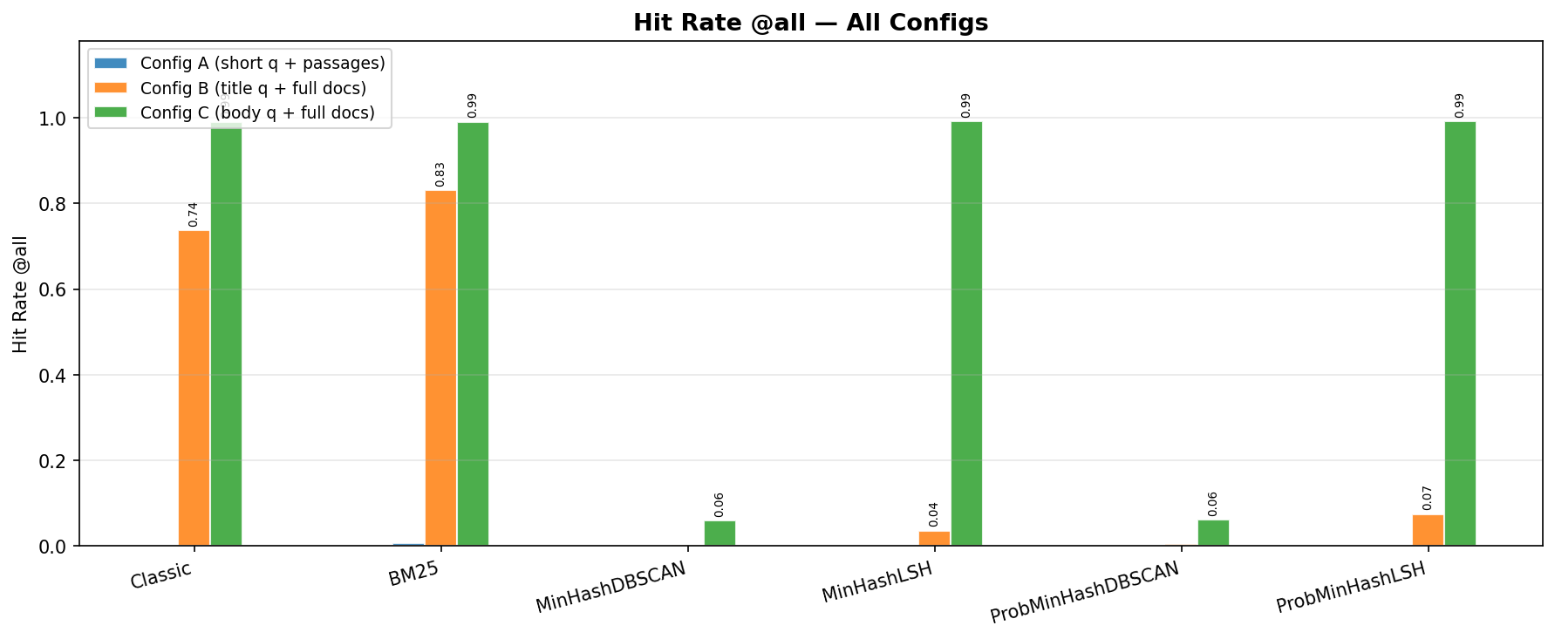
Figure 1 – Hit Rate @all for all six retrievers across the three experimental configurations.
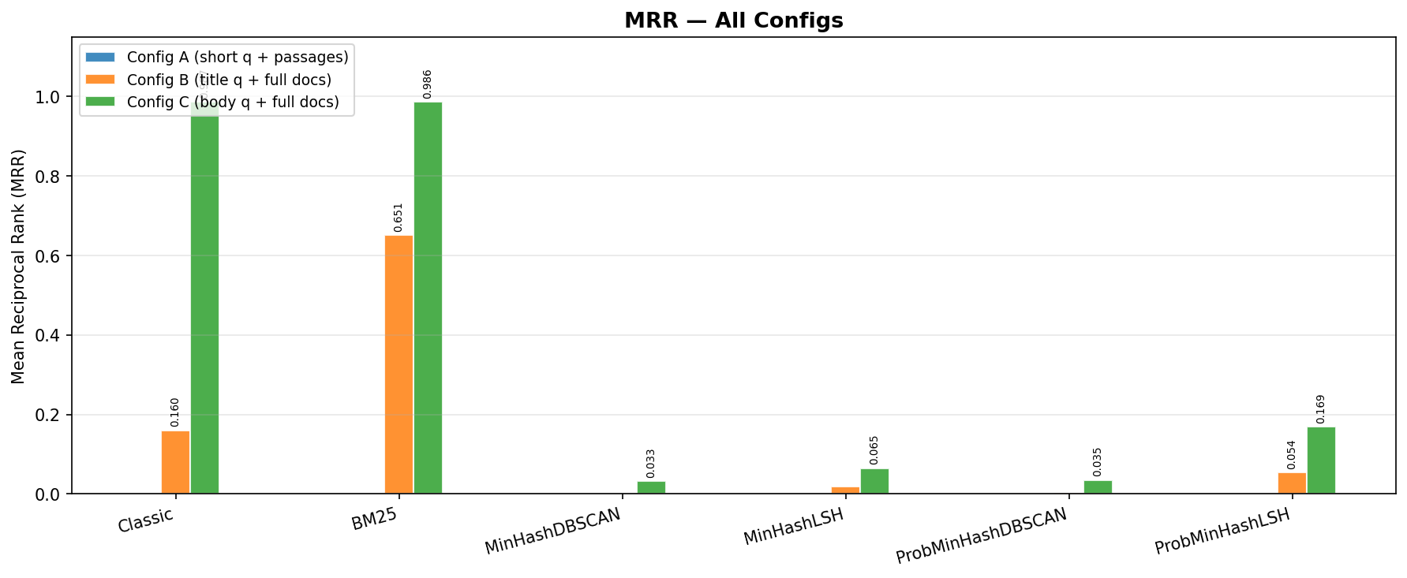
Figure 2 – Mean Reciprocal Rank (MRR) for all six retrievers across configurations.
4.3 Config A — Short Natural-Language Queries + Passage Corpus
Config A is the hardest setting: 1,000 natural-language queries against 100,000 short MS-MARCO passages with single ground-truth qrels. Every retriever essentially fails here. BM25 achieves a marginal 0.7% hit rate (7 out of 1,000 queries); Classic achieves 0%, as do all four sketch-based retrievers. This near-universal failure is expected: our threshold-based retrieval returns documents with significant term overlap, but natural-language queries and passages share very few exact terms, making sketch-based approaches unsuitable for open-domain QA (the task of answering natural-language questions sourced from a large, unrestricted corpus — such as Wikipedia — without prior knowledge of which document contains the answer; queries are typically short and conversational, while the corpus spans millions of diverse passages) without query expansion or dense retrieval.
Memory usage is low across all retrievers. Classic and BM25 consume ~3.9 MB per query, while LSH variants require only ~0.02 MB — a ~200× advantage. DBSCAN variants consume ~1.6–1.7 MB. Update latency reveals a key trade-off: Classic requires 0.77 s per update (DBSCAN re-clustering), BM25 takes 0.022 s, and MinHashLSH is fastest at ~0.001 s.
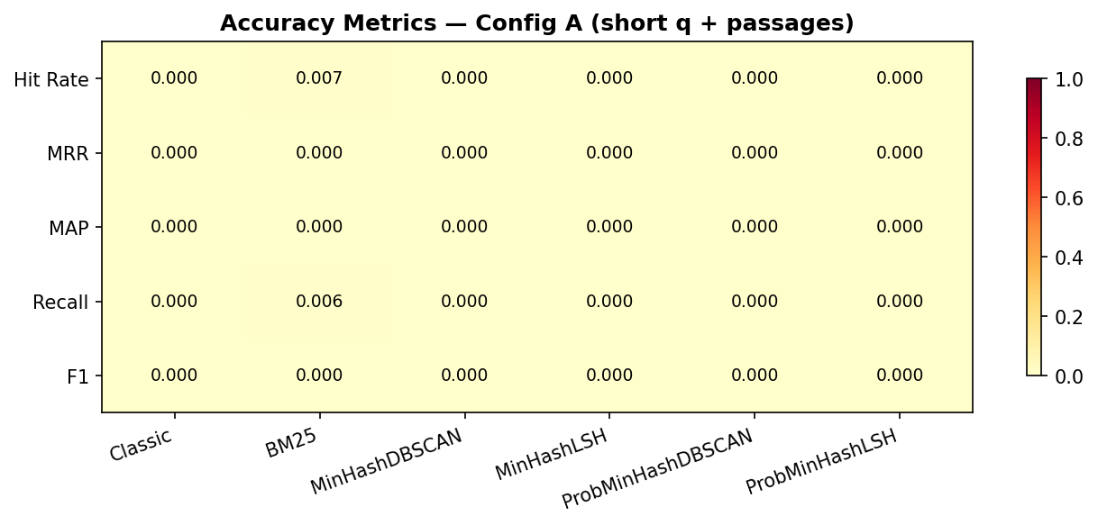
Figure 3 – Accuracy metrics heatmap for Config A. All retrievers score near zero on natural-language queries against a passage corpus.
4.4 Config B — Short Title Queries + Full-Document Corpus
Config B was designed as a controlled intermediate test between the short natural-language queries of Config A and the full document-body queries of Config C. Using a document's own title as the query guarantees maximum lexical overlap with exactly one document in the corpus — the title is, by definition, the most compact and unique lexical descriptor of that document. This makes Config B an upper-bound test for short-query retrieval: if a retriever cannot find a document when given its exact title, it cannot be expected to succeed on any shorter or less specific query. It also acts as a proxy for named-entity or look-up style queries (e.g., 'What is [Article Title]?'), which are common in knowledge-base question answering but structurally harder for sketch-based methods than full-body matching.
Config B uses document titles (~5 tokens) as queries. BM25 leads with 83.2% hit rate and MRR 0.651, confirming that probabilistic term-based scoring ranks the source document highly when given its own title. Classic (TF-IDF cosine) achieves 73.7% hit rate but much lower MRR (0.160), meaning it finds the document somewhere in a large result set but does not consistently rank it first.
All four sketch-based retrievers perform poorly on short title queries: MinHashDBSCAN (0.2%), MinHashLSH (3.6%), ProbMinHashDBSCAN (0.4%), and ProbMinHashLSH (7.5%). Short 5-token queries produce sparse MinHash signatures with high Jaccard distances from their source document. ProbMinHashLSH outperforms the other sketch retrievers (MRR 0.054), suggesting that probability-weighted hashing better captures title term importance. Memory per query is dominated by BM25 (3.46 MB) and Classic (1.39 MB), while all sketch variants use under 0.4 MB.
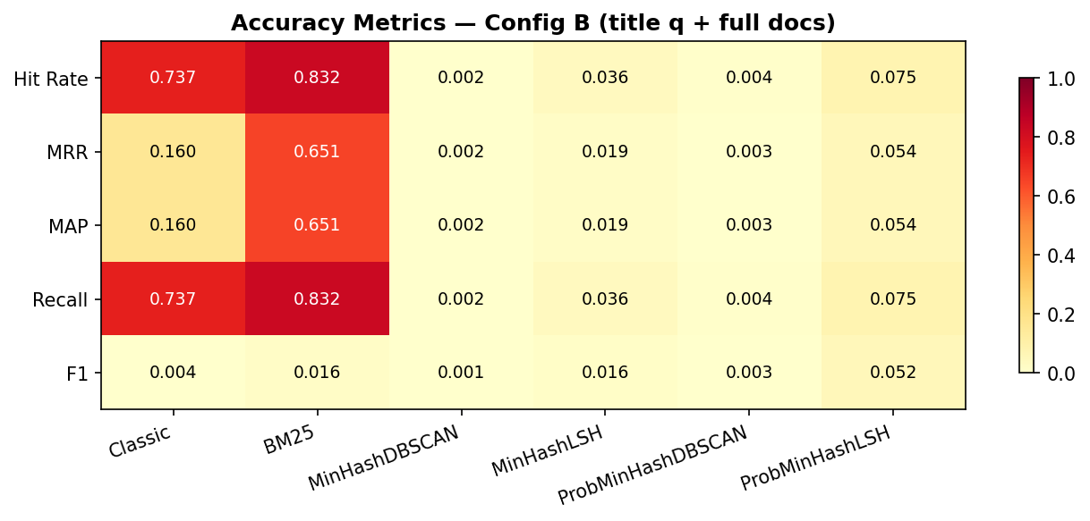
Figure 4 – Accuracy metrics heatmap for Config B. BM25 and Classic outperform sketch-based retrievers on short title queries.
4.5 Config C — Full Body Queries + Full-Document Corpus
Config C is the most informative configuration: full document bodies (~545 tokens) are used as queries against the 100,000-document corpus with self-referential ground truth, testing whether each retriever can match a document to its own content.
Classic and BM25 both achieve near-perfect performance: 99.1% hit rate and MRR ≈ 0.987 and 0.986 respectively. Both reliably surface the source document at the top of the result list when given its full body as the query.
The LSH-based sketch retrievers achieve excellent hit rates — MinHashLSH and ProbMinHashLSH both reach 99.2% — but significantly lower MRR values (0.065 and 0.169 respectively). This reveals an important characteristic of LSH retrieval: the source document is present in the returned bucket, but the bucket may contain many near-duplicate documents, so the correct document is not ranked first. ProbMinHashLSH’s higher MRR (0.169 vs. 0.065) demonstrates the value of probability-weighted hashing: by giving higher weight to informative (rare) terms, it better discriminates among documents sharing a cluster.
The DBSCAN-based retrievers perform poorly despite the rich query context: MinHashDBSCAN (5.9% hit rate, MRR 0.033) and ProbMinHashDBSCAN (6.2%, MRR 0.035). With 100,000 full-text documents, DBSCAN clusters are too coarse — many documents share the same cluster due to topic similarity, so the source document is often not co-clustered with its query.
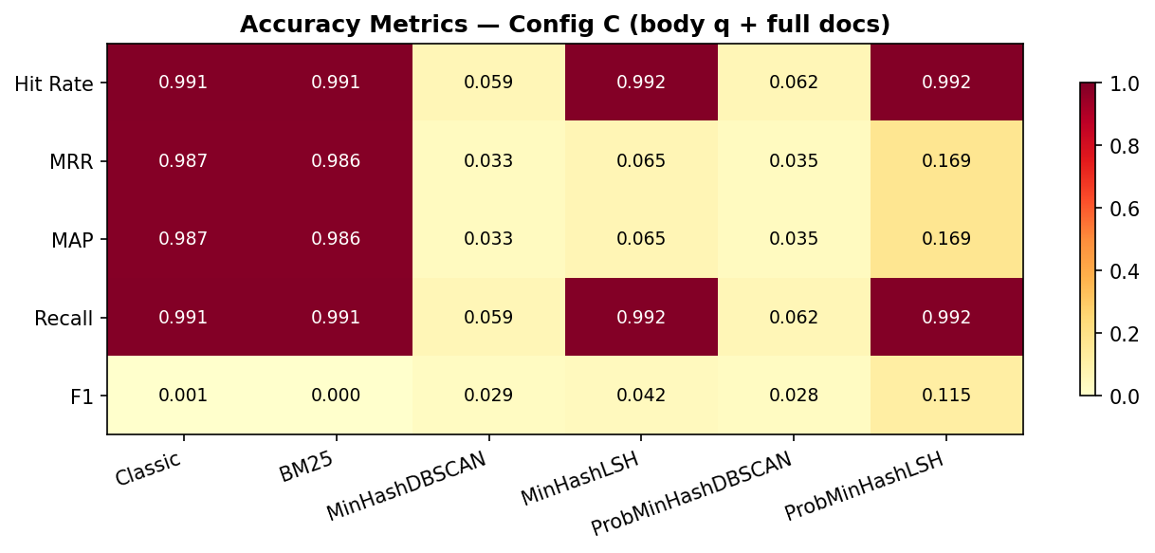
Figure 5 – Accuracy metrics heatmap for Config C. Classic and BM25 approach perfect performance; LSH variants achieve high hit rates but lower ranking quality.
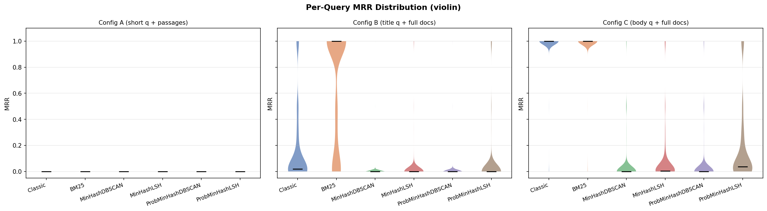
Figure 6 – Per-query MRR distribution across configurations. Config C shows bimodal distributions for sketch retrievers: either the document is found (MRR > 0) or completely missed (MRR = 0).
4.6 Memory Efficiency
Figure 7 compares peak query memory across all configurations. LSH-based retrievers (MinHashLSH: ~0.02 MB, ProbMinHashLSH: ~0.02–0.14 MB) consume dramatically less memory than Classic (~1.4–2.2 MB) and BM25 (~3.5–3.9 MB). DBSCAN variants occupy an intermediate ~0.4–1.7 MB. This advantage is consistent across all three configurations.
Figure 8 plots MRR against memory usage to visualise the accuracy-efficiency frontier. In Config C, ProbMinHashLSH uses only 0.14 MB and achieves MRR 0.169 — an order of magnitude less memory than BM25, with a 6× trade-off in MRR. For applications where memory is constrained and a near-100% hit rate is acceptable with imperfect ranking, the LSH variants offer a compelling alternative.
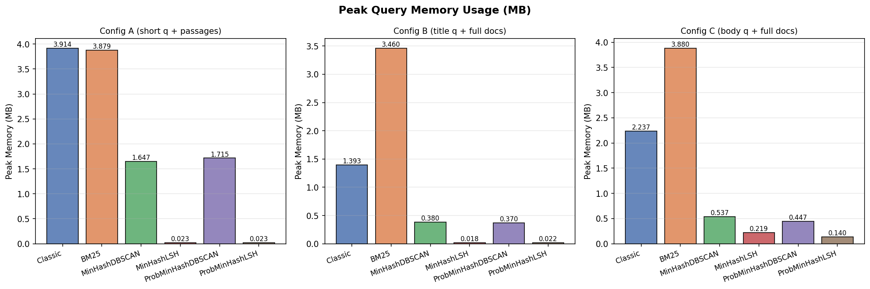
Figure 7 – Peak query memory (MB) by retriever and configuration. LSH variants use ~0.02 MB vs. ~3.9 MB for BM25, a ~200× advantage.
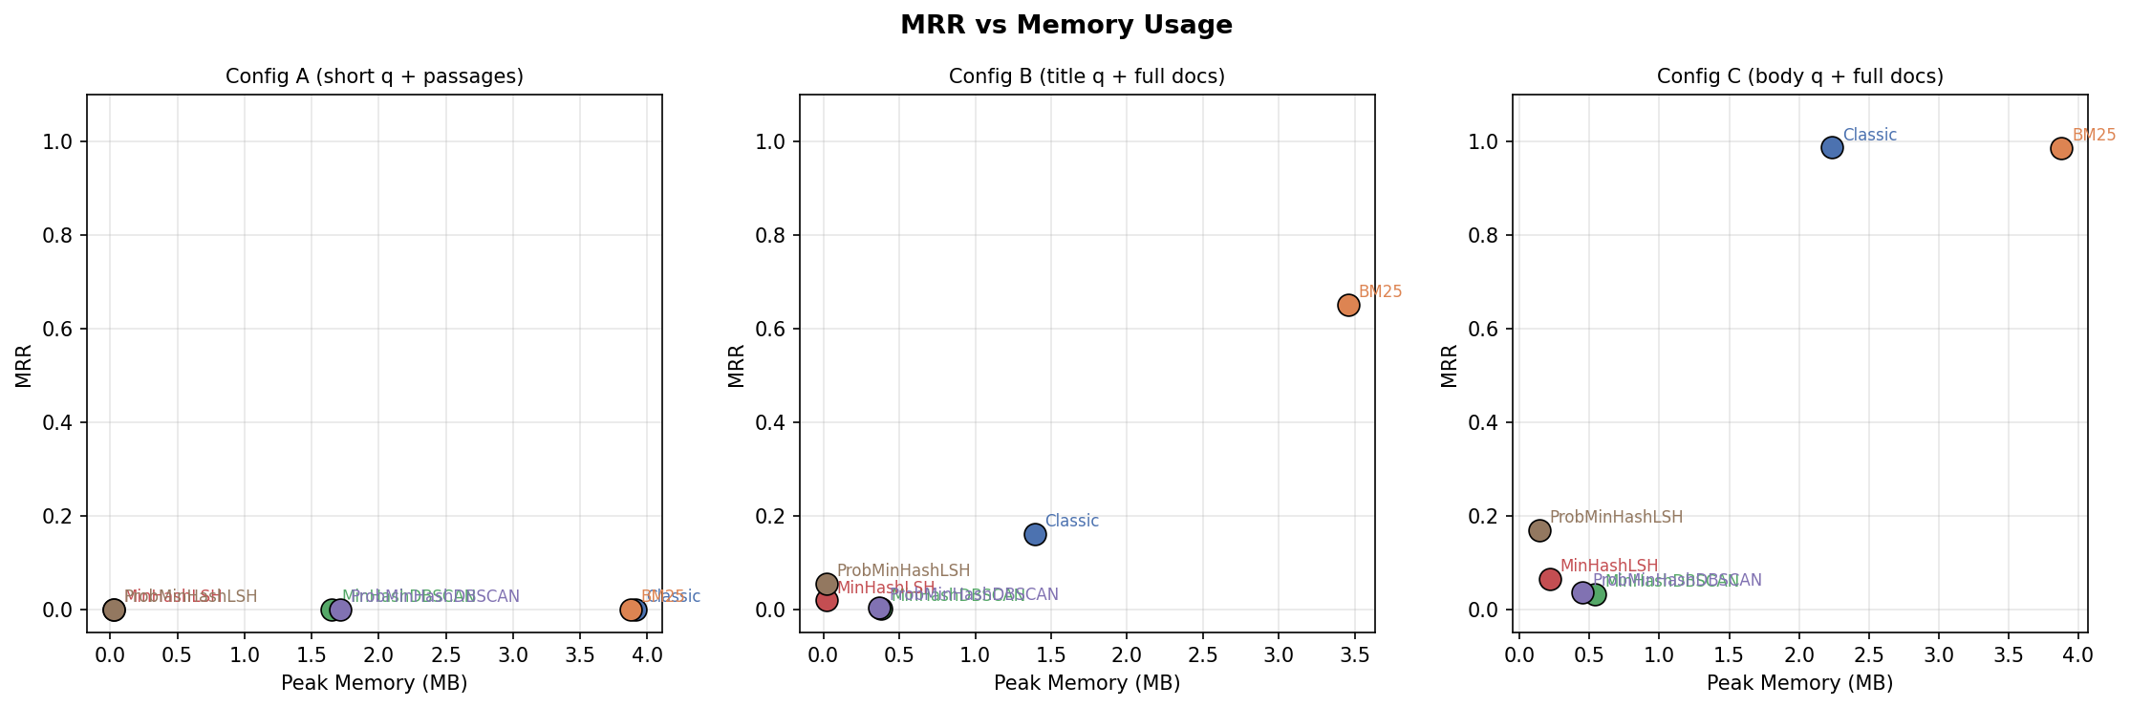
Figure 8 – MRR vs. peak memory (MB). ProbMinHashLSH lies on a favourable efficiency frontier in Config C.
4.7 Corpus Update Latency
Corpus update latency was measured by timing sequential single-document insertions. Classic incurs the highest cost: 16.8 s per update (median), because every insertion triggers a full DBSCAN re-clustering of the growing corpus, making it impractical for streaming scenarios. BM25 is much faster at 0.43 s (global IDF recomputation required). The MinHash variants are near-instant: MinHashDBSCAN ~0.14 s (re-clusters MinHash signatures); MinHashLSH ~0.005 s (single index insertion); ProbMinHashDBSCAN <0.001 s; ProbMinHashLSH ~0.012 s.
LSH-based retrievers are therefore uniquely suited for streaming or continuously-updated corpora: sub-millisecond to ~12 ms update latency combined with ~99% hit rate in the body-query setting makes them a compelling choice for real-time RAG pipelines.
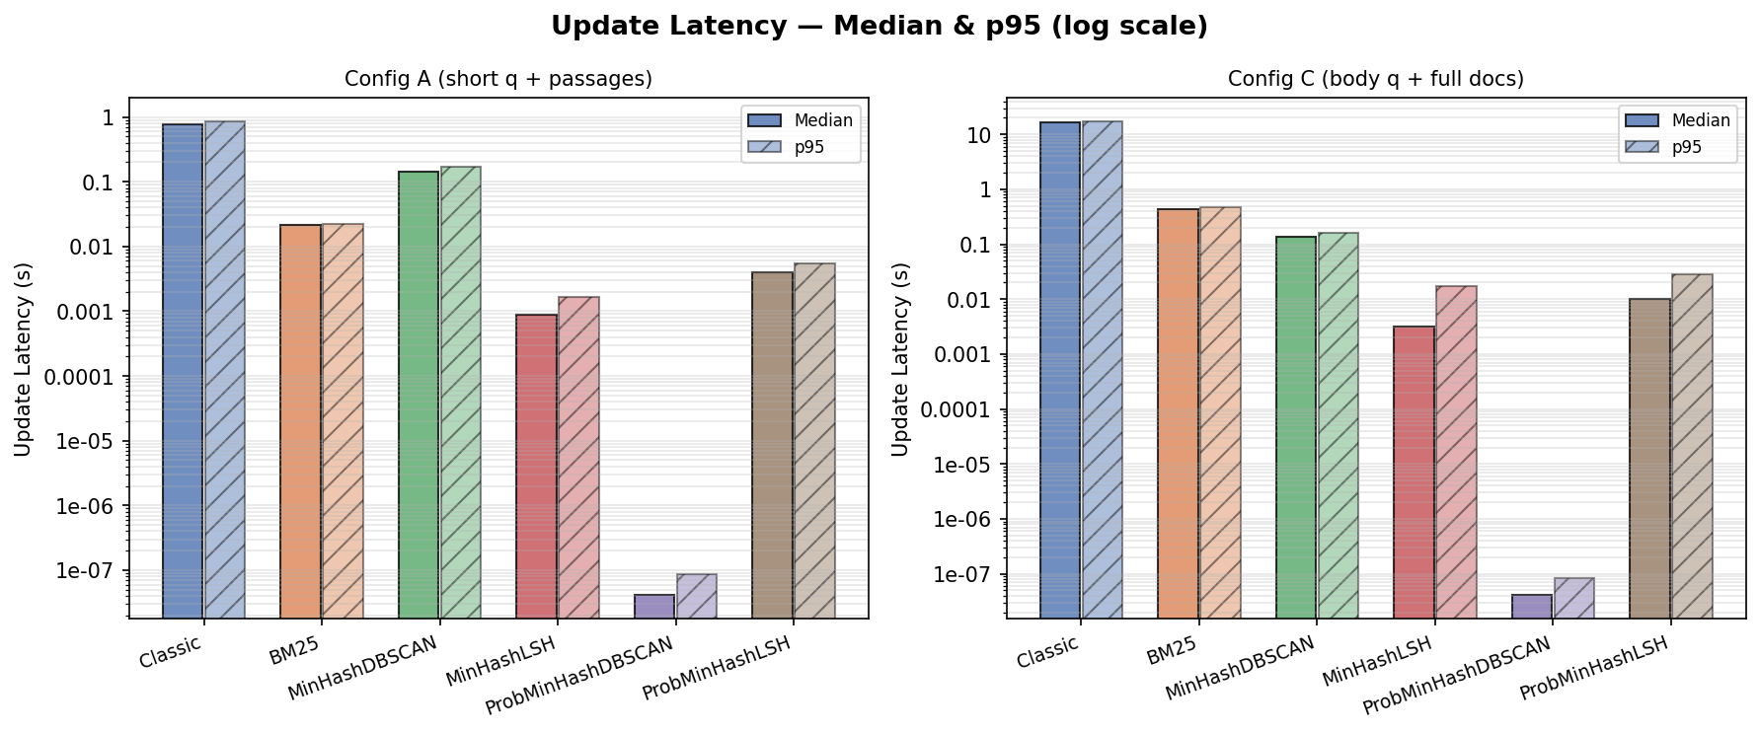
Figure 9 – Per-update latency (median and p95, log scale). Classic is ~3,000× slower to update than MinHashLSH.
4.8 Result Set Size
Figure 10 shows the mean number of documents returned per query. BM25 returns on average 1,590 documents per query in Config A. In Config C, Classic and BM25 return ~8,567 and ~12,569 respectively (body-to-body matching surfaces many near-duplicates), while DBSCAN variants return only ~3 documents (cluster members) and LSH variants return ~412–1,142 documents (bucket members).
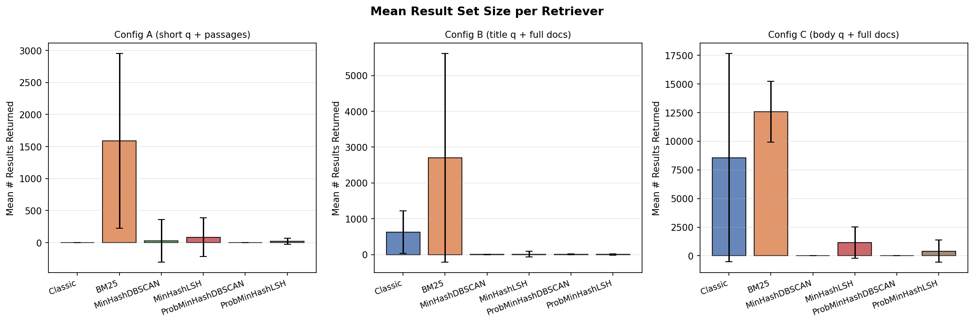
Figure 10 – Mean number of results returned per query by retriever and configuration.
4.9 Summary of Results
Table 1 summarises the key metrics for each retriever across the three configurations.
Retriever | Config | Hit Rate | MRR | MAP | Memory (MB)
Classic | A | 0.0% | 0.000 | 0.000 | 3.91
BM25 | A | 0.7% | 0.000 | 0.000 | 3.88
MinHashDBSCAN | A | 0.0% | 0.000 | 0.000 | 1.65
MinHashLSH | A | 0.0% | 0.000 | 0.000 | 0.023
ProbMinHashDBSCAN | A | 0.0% | 0.000 | 0.000 | 1.72
ProbMinHashLSH | A | 0.0% | 0.000 | 0.000 | 0.023
Classic | B | 73.7% | 0.160 | 0.160 | 1.39
BM25 | B | 83.2% | 0.651 | 0.651 | 3.46
MinHashDBSCAN | B | 0.2% | 0.002 | 0.002 | 0.380
MinHashLSH | B | 3.6% | 0.019 | 0.019 | 0.018
ProbMinHashDBSCAN | B | 0.4% | 0.003 | 0.003 | 0.370
ProbMinHashLSH | B | 7.5% | 0.054 | 0.054 | 0.022
Classic | C | 99.1% | 0.987 | 0.987 | 2.24
BM25 | C | 99.1% | 0.986 | 0.986 | 3.88
MinHashDBSCAN | C | 5.9% | 0.033 | 0.033 | 0.537
MinHashLSH | C | 99.2% | 0.065 | 0.065 | 0.219
ProbMinHashDBSCAN | C | 6.2% | 0.035 | 0.035 | 0.447
ProbMinHashLSH | C | 99.2% | 0.169 | 0.169 | 0.140
Table 1 – Summary of retrieval accuracy and memory for all six retrievers across three configurations. Config A = short NL queries; Config B = title queries; Config C = full body queries.
4.10 Key Findings
The experiments reveal the following key findings:
Query length is the dominant factor in retrieval success. Short NL queries (Config A) are fundamentally difficult for all lexical retrievers; full-body queries (Config C) are trivially easy for Classic and BM25, and highly effective for LSH-based sketch retrievers.
BM25 is the strongest retriever in the mixed setting (Config B): 83.2% hit rate and MRR 0.651 vs. Classic’s 73.7% / 0.160. BM25’s length normalisation gives it an edge when document bodies are much longer than the query.
LSH-based sketch retrievers (MinHashLSH, ProbMinHashLSH) achieve near-perfect hit rates in Config C (99.2%) using only ~0.02–0.14 MB of memory — one to two orders of magnitude less than BM25. ProbMinHashLSH achieves MRR 0.169 by exploiting term-frequency weights.
DBSCAN-based retrievers consistently underperform LSH variants. At 100,000 full-text documents, DBSCAN cluster granularity is too coarse, yielding only 5.9–6.2% hit rate in Config C.
For streaming applications, MinHashLSH and ProbMinHashLSH are the clear winners: ~0.005–0.012 s update latency, ~0.02–0.14 MB memory, and ~99% hit rate in the body-query setting.
V. Conclusion
This paper extended Dr. Yehezkel's MinHash-DBSCAN retrieval framework — originally designed for GenAI output verification, where queries are long — to the RAG setting, where queries are typically short natural-language sentences. We evaluated six retrievers (Classic TF-IDF, BM25, MinHashDBSCAN, MinHashLSH, ProbMinHashDBSCAN, ProbMinHashLSH) across three experimental configurations on 100,000 MS-MARCO documents, measuring accuracy (Hit Rate, MRR, MAP), memory footprint, and corpus update latency.
The central finding is that query length is the dominant factor governing retrieval success for all lexical methods tested. In Config A — the setting that most closely resembles a real RAG pipeline, with short (~10-token) natural-language queries against a passage corpus — every retriever fails. BM25 achieves only a 0.7% hit rate; all sketch-based methods score 0%. This is not a failure of any individual algorithm but a fundamental limitation of lexical overlap: short, conversational queries share too few exact terms with the passages that answer them. The original Yehezkel approach was designed for long GenAI outputs, which naturally share many tokens with their source documents; applying it unmodified to short RAG queries removes its key advantage.
When queries carry sufficient lexical signal, the picture changes significantly. In Config B (title queries, ~5 tokens), BM25 reaches 83.2% hit rate and MRR 0.651, outperforming Classic TF-IDF (73.7% / 0.160) and all sketch-based retrievers (best: ProbMinHashLSH at 7.5% / 0.054). In Config C (full document-body queries, ~545 tokens), Classic and BM25 approach perfect performance (99.1% hit rate, MRR ~0.987), while the LSH-based sketch retrievers also achieve 99.2% hit rate — at one to two orders of magnitude lower memory (0.02–0.14 MB vs. 3.5–3.9 MB for BM25) and near-instant update latency (~0.005–0.012 s vs. 16.8 s for Classic).
Among the sketch-based approaches, LSH consistently outperforms DBSCAN. At 100,000 documents, DBSCAN clusters become too coarse: many topically similar documents share a cluster, so the correct document is rarely co-clustered with a short query, yielding only 5.9–6.2% hit rate in Config C. LSH's bucket-based structure is more granular and scales gracefully, achieving 99.2% hit rate in Config C with sub-millisecond query latency. This suggests that for large corpora, LSH is a more suitable companion to MinHash than DBSCAN, contrary to the structure assumed in Yehezkel's original design.
ProbMinHash4 (weighted by TF-IDF) consistently improves ranking quality over unweighted MinHash when paired with LSH. In Config C, ProbMinHashLSH achieves MRR 0.169 compared to MinHashLSH's 0.065 — a 2.6x improvement in ranking precision at near-identical hit rate and memory cost. This demonstrates the value of incorporating term-frequency weights into the sketching stage: even modest weighting helps discriminate among documents within the same LSH bucket. The improvement is smaller for DBSCAN variants (MRR 0.035 vs 0.033), confirming that ranking gains from ProbMinHash are only realised when the retrieval structure itself is fine-grained enough.
For streaming and continuously-updated RAG pipelines, MinHashLSH and ProbMinHashLSH are the clear recommendation: corpus updates take ~5–12 ms (single index insertion), compared to 16.8 s for Classic (full DBSCAN re-clustering) and 0.43 s for BM25 (global IDF recomputation). Combined with ~0.02–0.14 MB per-query memory, these methods are uniquely suited to real-time retrieval at scale — provided that queries are long enough to generate dense MinHash signatures.
Limitations and Future Work
The primary limitation of this work is that all methods tested are purely lexical: they rely on shared token overlap between query and document. This makes them fundamentally unsuited for the short natural-language query setting (Config A) that defines most real-world RAG systems today. Future work should investigate hybrid pipelines that use MinHashLSH as a fast pre-filter to narrow the candidate set, followed by a lightweight dense re-ranker (e.g., a bi-encoder or cross-encoder) to handle semantic gaps. Such a design could preserve the memory and update-latency advantages of LSH while recovering the accuracy needed for open-domain QA.
Additionally, the DBSCAN hyperparameters (eps=0.85, min_samples=2) were fixed across all corpus sizes. Adaptive or hierarchical clustering strategies may better handle the granularity problem observed at 100,000 documents. Finally, extending the evaluation to larger corpora (1M+ documents) and multilingual datasets would better characterise the scalability limits of each approach. The theoretical sublinear query complexity of both DBSCAN and LSH-based retrieval makes them strong candidates for such scale, and empirical validation at that size remains an important open question.

